Incomplete dominance
Incomplete dominance is when a dominant allele, or form of a gene, does not completely mask the effects of a recessive allele, and the organism’s resulting physical appearance shows a blending of both alleles. It is also called semi-dominance or partial dominance. It was first discovered in Mirabilis jalapa or four o' clock plant.
Incomplete dominance can occur because neither of the two alleles is fully dominant over the other, or because the dominant allele does not fully dominate the recessive allele. This results in a phenotype that is different from both the dominant and recessive alleles, and appears to be a mixture of both. For eg., in roses, the allele for red colour is dominant over the allele for white colour. But, the heterozygous flowers with both the alleles are pink in colour.
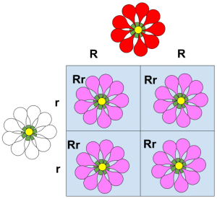
This Punnett square shows incomplete dominance. The homozygous red flower has two dominant red alleles, and these are represented by the letters RR. The homozygous white flower is represented by rr. Their offspring are all heterozygous Rr, and they have pink flowers. This is the first filial generation, or F₁. When the F₁ generation cross-pollinates, their offspring will be RR, Rr, and rr in a 1:2:1 ratio. Some of their offspring (the F₂ generation) will inherit two R alleles, some will inherit two r alleles, and some will inherit both.
A child born to a parent with straight hair and a parent with curly hair will usually have wavy hair, or hair that is a little curled, due to the expression of both curly and straight alleles.

